**MECH 2400 Final Project: Ender 3 Pro Assembly**

**Richard Malstrom**

**MECH 2400 Spring 2025**

Contents

Introduction 2

Technical Discussion 2

Results 3

Conclusion 3

References 3

# Introduction

My project is a CAD assembly of a Creality Ender 3 Pro 3D printer. I chose this project because 3D printing is my main hobby, so I naturally have an attachment to modeling a 3D printer. “Why the Ender 3 Pro?” It was my first 3D printer in 2020, and it has been my Old Faithful to this day. Another conscious decision to model this was because of the part's simplicity. There are dozens of parts, but many of the parts are very simple and industrial; these are Autodesk Inventor's bread and butter. There are very few curves, mostly straight lines, and predictable geometry.

# Technical Discussion

I started modeling my project with the aluminum extrusions, of which there are 8 (Bottom Braces (L&R), Y-Axis, X-Axis, Side Braces(L&R), Top Brace, and the Center Bottom Brace). I started with this because I naively believed they would be easy and give me good practice with constraint management and using minimal dimensions. I was half correct; I gained valuable experience with constraints and dimension management, but they were anything but easy. The 2020 extrusions were simple enough, but the 2040 and 4040 extrusions forced me to overcome some challenges to get them to work well. For example, the 4040 Extrusion side profile would consistently lock up and say that I was either missing dimensions (but the part couldn’t move) or that I had a -1 dimension somehow. Regardless, I finished the 2040 and 4040 similarly; when they broke, I would delete them and start again. In the extrusions, I used the extrude and hole tools. This will continue for most of the parts. I used extrude and hole extensively throughout my project with a good mix of rectangular patterns.

The rest of the project development was rather linear. My workflow ended up being, think of a part I needed, find the dimensions from Creality’s Github page (which was missing some dimensions sometimes), then test fit the part into the assembly, and finally if needed I would grab the real life part from my Ender 3 Pro and use calipers to measure the dimensions that were missing.

Finally, once all of the parts were mounted, I went through with the bolts and nuts to finish the appearance that the assembly was complete and held together. To do this, I grabbed a sloped head bolt and a standard hex bolt from the content center and went around and inserted them into all of the appropriate holes for each bolt.

The largest side-quest in this project was all of the exploded views. Due to the scale of the project and the number of parts and fasteners in the assembly, it doesn’t seem reasonable to create one exploded view for the whole project. Instead, I copied and pasted parts from the main assembly into separate assembly files to create “subassemblies” that could make the exploded view. I chose not to comprise the main assembly with subassemblies because I wanted to keep the motion of the different parts simple and realistic.

I was able to fit most of the tools into the project, but some just didn’t mesh well with my project. Naturally, I used Extrude and Hole many times throughout this project, on just about every part. I used the Rectangular Pattern tool on the bottom sheet metal enclosure, and I used the Revolve tool on the nozzle. I used other tools and a ton of constraints, but those are the ones pertinent to this assignment. Joints and constraints were a massive part of the assembly, so I used dozens and dozens of those as well. The content center was where I got just about every fastener, except for specific ones like the T-Slot nut, because they weren’t on the content center.

# Results

I believe that the project came out well, and as I was hoping. There were certain corners cut that will probably haunt me for a while, but they seemed appropriate for the scope of the class. These limits were things like getting an accurate PCB for the LCD and motherboard, running cables to the motors and screens, the belts for the movement control, and finally the PTFE tube to run the filament to the hotend.

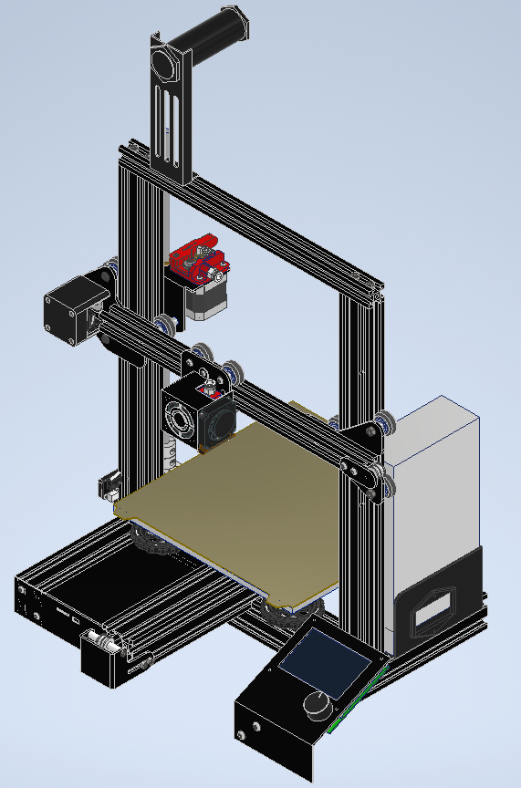

This is the final Isometric view of the project. Notes: There is a placeholder for the power supply and LCD; there are no belts, which allows the assembly to move around semi-realistically. I would attach the full part and assembly drawings but there are around 60 of them, so I will attach those as a separate PDF file for ease of use. I will do the same with the screenshots.

# Conclusion

Overall, the project did not give me many difficulties. This was probably due to the choice of project and choosing fact that it had basic geometries. I learned a ton about constraints and proper dimensioning; the struggles with the extrusions forced me to improve and evolve in my constraint usage. I am still trying to improve on adding dimensions to the drawings. In the future, I would want to make certain parts more accurate and learn how to make some of the extremely complicated parts of the extruder, and maybe adaptive springs and cables. I do plan on doing this sort of project again, hopefully designing my custom printer next time. For that, I will be more thoughtful about the orientation of parts when I am modeling them. There were a couple of times during the development that I had to go back to my parts and reorient them for either drawings or for the ease of assembly. So, for the future, I will use better naming conventions from the beginning and be much more careful about my file organization.

# References

(PDFs used to create all parts, excluding aluminum extrusions and parts I downloaded)

Creality3DPrinting. “Ender-3/Ender-3 Mechanical/PDF at Master · Creality3dprinting/Ender-3.” *GitHub*, 30 June 2018, github.com/Creality3DPrinting/Ender-3/tree/master/Ender-3%20Mechanical/PDF.

(CAD Model for the wheels and bearings)

Joednemesis. “Free CAD Designs, Files & 3D Models: The Grabcad Community Library.” *Free CAD Designs, Files & 3D Models | The GrabCAD Community Library*, 19 Jan. 2021, grabcad.com/library/wheel_o24-4mm-1.

(Dimensions for the Aluminum Extrusions)

<https://ae01.alicdn.com/kf/S7f5df6f6e43a47c1a4b23e417535e5d4v.jpg>

(Where I obtained other step files, including: )

Creality3DPrinting. “Ender-3/Ender-3 Mechanical/PDF at Master · Creality3dprinting/Ender-3.” *GitHub*, 30 June 2018, https://github.com/Creality3DPrinting/Ender-3/tree/master/Ender-3%20Mechanical/STP.

(Stepper Motor)

Syahroni, Ivan H. “Free CAD Designs, Files & 3D Models: The Grabcad Community Library.” *Free CAD Designs, Files & 3D Models | The GrabCAD Community Library*, 30 June 2020, grabcad.com/library/stepper-motor-nema17-17hs4401-42-mm-1.